CSE 581

**Lab 1: Database Account Setup**

**Steps:**

1. Follow the steps described in class to create your database environment.
   1. Use the web application to create your database environment.

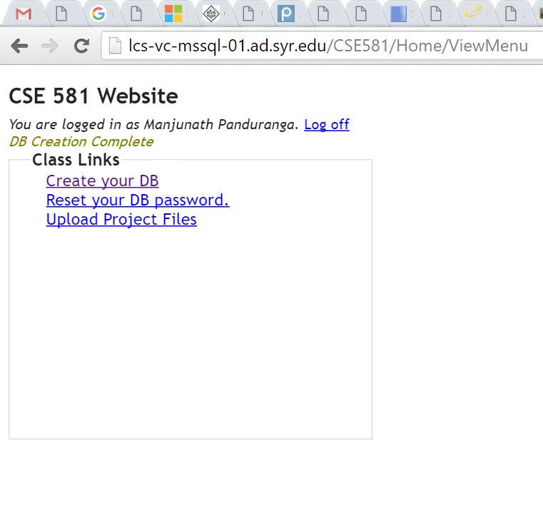

* 1. 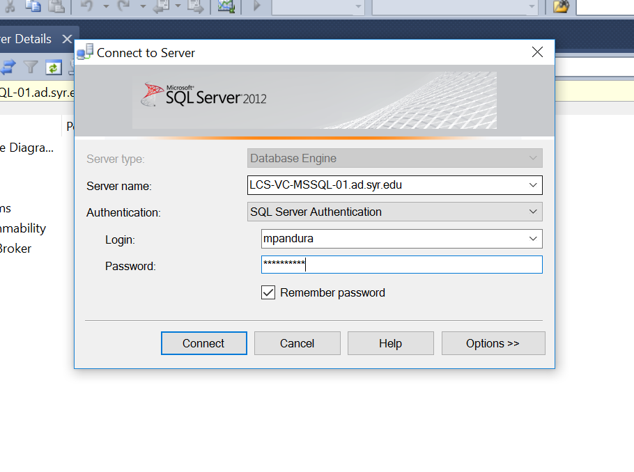Make sure the creation was successful by connecting to the server, making sure you can login (***screenshot***) as well as access your database (***screenshot)***